Contents

CHAPTER ONE 3

INTRODUCTION 3

1.0 Background of the Study 3

1.1 Problem Statement 4

1.2 Aim and Objectives 4

1.3 Significance of the study 5

1.4 Scope of the study 5

1.5 Limitations of the study 6

1.6 DEFINITION OF TERMS 6

CHAPTER TWO 9

LITERATURE REVIEW 9

2.1 EXPERT SYSTEMS 9

2.2 MEDICAL EXPERT SYSTEM 10

2.2.1 MYCIN 11

2.2.2 ONCOCIN 12

2.2.3 DIAVAL 13

2.2.4 EMYCIN 13

2.3. MEDICAL EXPERT SYSTEM IN RURAL AREAS 14

2.3.1 DIAGNOSIS 14

2.3.2 CONSULTATION SERVICES 14

2.3.3 TRAINING 14

2.4. ARCHITECTURE OF AN EXPERT SYSTEM 15

2.4.1 THE KNOWLEDGE BASE 16

2.5 DEPRESSION 17

2.5.1 Subtypes of Depression: Anaclitic and Introjective Depression Subtypes. 18

2.5.2 Depression: Patterns of Natural Course, Relapse, and Recovery 19

2.6 ARTIFICIAL INTELLIGENCE 21

2.6.1 WHY RESEARCH ARTIFICIAL INTELLIGENCE SAFETY? 22

2.6.2 HOW CAN ARTIFICIAL INTELLIGENCE BE DANGEROUS? 23

2.6.3 WHY THE RECENT INTEREST IN ARTIFICIAL INTELLIGENCE SAFETY 24

2.6.4 THE TOP MYTHS ABOUT ADVANCED 25

2.6.5 TIMELINE MYTHS 25

2.6.6 CONTROVERSY MYTHS 27

2.7 RELATED WORK 28

CHAPTER THREE 29

ANALYSIS AND DESIGN 29

3.0 INTRODUCTION 29

3.1    Analysis of the Existing System 30

3.1.1    Advantages of the Existing System 30

3.1.2    Disadvantages of the Existing System 30

3.2    Analysis of the Proposed System 31

3.2.1 Advantages of the proposed system 32

3.2.2 Disadvantages of the Proposed System 33

3.3    Methodology 33

3.4    System Design 34

3.5    Use Case Diagram 35

3.6 Proposed System Flow Chart 36

3.6 Software Requirements 37

3.6.1 Software tools used 37

3.7 Hardware Requirements 40

CHAPTER FOUR 41

SYSTEM DESIGN AND IMPLEMENTATION 41

4.1 Introduction 41

4.2 Objective of the new system 41

4.3 Landing Page (Home Page) 42

4.4 Database Specification 42

4.5 Input/Output Screen/Format 45

4.5.1 Login Module 46

4.5.3 Admin Symptom Input Module 46

4.5.4 Admin dashboard Symptom Output Module 47

4.5.6 Result Display Module 48

The 4.6 Hardware and Operating System requirement 49

4.6.1 Hardware Specifications 49

4.6.2 Software Specifications: 50

4.7 Software testing 50

4.7.1 Testing Methods 51

CHAPTER FIVE 54

SUMMARY, CONCLUSION AND RECOMMENDATIONS 54

5.1 Summary 54

5.2 Conclusion 54

5.3 Recommendation 54

# 

# CHAPTER ONE

# INTRODUCTION

## 1.0 Background of the Study

Depression is a common mental disorder, characterized by sadness, loss of interest or pleasure, feelings of guilt or low self-worth, disturbed sleep or appetite, feelings of tiredness, and poor concentration. It affects approximately 350 Million people worldwide. Various factors including but not limited to physical, mental, social, biological causes, may lead to Depression. Depression may manifest in one of the many types such as Major Depression, Bipolar or Seasonal Depression, to name a few. Depression diagnosis is not easy due to the fact that there are no direct physical and /or pathological indicators. A lot depends on the question-answer type diagnosis by the doctor. While there are multiple channels (like support forums, counselors, guide websites, etc.) which provide online support for patients in terms of guidelines to identify depression symptoms and look for possible remedies, while all these has its upsides the downside to that is that most of this forums are not very affordable as the charges are usually exorbitant, the ones that are free are not private and the forums are usually made up of non professional counselors.

In this research we are proposing a web based expert system for depression management, the system will be able to diagnose the different kinds of depression cases and proffer possible solution on how to manage the situation.

## 1.1 Problem Statement

Depression cases are increasing on a daily bases, students doing poorly in school, increased suicide rate, and many advanced mental degradations that arises from undiagnosed cases of depression are on the rise and yet very little is being done to tackle the situation,

And since most people do not have time to check on their mental health because of other priorities and feeling worried that others will think they need to be confined in an asylum, aside issues that borders on time, Nigerians are yet to embrace the culture of going for routine mental health checkup or any form of health checkup as it were.

In light of these it is obvious that traditional method of diagnosing and managing depression may not solve the problem of depression in this part of the world. Hence the need for a web based depression management system.

## 1.2 Aim and Objectives

The aim of the study is to assemble a knowledge base that is common to the diagnosis and management of most depression symptoms, and then develops an online system that will help users to test for depressive disorder.

The objectives of this study are to develop a system:-

1. That a user can interact with to identify the type of depression he/she is diagnosed with, if any.
2. That a user can interact with to determine the severity of the user’s condition.
3. That will provide a simple user interface.

## 1.3 Significance of the study

This will help to educate the public on the dangers of depression and will also provide a platform for quick diagnosis and possible treatments. It is worthy of note that if the society does not start thinking in this line of providing a web based depression management system then we will continue to experience an increase of the many manifestation of depression in the form of suicides, lack of motivation, other associated degrading mental ailment and so on

## 1.4 Scope of the study

The research study will focus on the following areas

* The proposed system can determine the forms of depression disorder, bipolar Disorder, and post Natal Depression.
* The proposed system can determine the degree of depression such as mild, moderate and severe.
* The proposed system can provide brief but effective treatment. These include behavioral inspiration, guided self-management, and treatment monitoring

## 1.5 Limitations of the study

The proposed system has the following limitations:

* The proposed system cannot advice any medical prescriptions
* The proposed system cannot give treatment for severe conditions

In addition to the above mentioned limitations the proposed system cannot contain all it is suppose to because of the following constraints:

* **TIME FACTOR: -** The aim that is given for the research on this study is very limited making it impossible to go further into the research.
* **UNAVAILABILITY OF THE NEEDED INFORMATION: -** Seeing that only a few depression therapists are available and easily accessible in this country, it was difficult for me to get much informant for the work.
* **LIMITED RESOURCES: - Because** of the cost in transportation and other financial demands, it was not possible to get all the information needed for an elaborate work.

## 1.6 DEFINITION OF TERMS

* DEPRESSION

Depression, in psychology, is a mood or emotional state that is marked by feelings of low self-worth or guilt and a reduced ability to enjoy life.

* EXPERT

And expert is one who is extraordinarily capable or knowledgeable in a particular field of study

* SYSTEM

A collection of organised things

* EXPERT SYSTEM

According to Daniel L. Stotink and his friends in a book “computer and applications an introduction to data processing” expert system is also a knowledge based system. It is a complex software (program), designed to imitate the thought processes and decision making patterns of human experts in a given field. The expert system is an off-spring of artificial intelligence (AI) and it is developed using the programming techniques of A1. When the expert knowledge of human being in a domain of activity is stored in the computer, such that the computer repository of this expert knowledge in some way, reaching the same conclusion as the expect himself and efficiently replacing him, an expert system or knowledge based system results.

* KNOWLEDGE – BASE

A repository in a computer of an expert’s knowledge in a given domain.

* DOMAIN EXPERT

It is not easy to effectively replace the human being with just one expert system rather; a piece meal approach is used in which an expert system is instrumental for a narrow domain to mimic the human being in one activity at a time.

* REASONING BY INDUCTION

If in an expert system past conditions and corresponding decisions reached are stored such that where a new condition arises. The computer tries to match it with one of the previous condition, the approach is known as reasoning by induction.

* HEURISTIC

In general, the experience a human being acquires in any area of human endeavour is often in the form of rules of thumb which the human experts falls upon when confronted with a new but related situation. Such rules of thumb are known as heuristic in artificial intelligence terminology.

* INFERENCE ENGINE

The knowledge of an expert can be represented as a set of rules that allows the computer to make human like decisions on the subject. In other words, knowledge – base can actually be in the form of rules and not only in the form of tables of information which can also be used as alternative approach. The computer program written to shift through the set of rules representing human expert knowledge so as to reach a decision on the current situation can be referred to as inference mechanism or inference engine.

# CHAPTER TWO

# LITERATURE REVIEW

## 2.1 EXPERT SYSTEMS

Expert systems are a branch of applied artificial intelligence (3). An expert system is an intelligent computer program which captures the knowledge of a human expert (4). This information is then used to solve real-world problems in an automated fashion (5).The basic idea behind these systems is simply that expertise on a specific subject is transferred from a human to a computer(3). The main purpose of knowledge-based expert systems is to make the knowledge of a human expert and their experiences to be more commonly available, particularly in areas where they are not readily available(6). The quality, efficiency, and competitive control of expert system operations have increased over the years (4). Expert systems are applied in many different areas (1). In medicine expert systems are used to diagnose a medical problem and predict particular diseases (5), as well as to assist a physician in diagnosing medical problems of a patient or help interpret medical test results (4). Some of these systems are designed to train medical school students.

In chemistry expert systems are used to help interpret data from an experiment and they can assist in the planning and monitoring of the experiments and interpreting test data. They are very useful in determining molecular structures from mass spectrogram data (4). Whereas in computer science expert systems are used to assist in solving time consuming tasks (7). They are also used to design and diagnose a variety of computer systems (4).

## 2.2 MEDICAL EXPERT SYSTEM

In medicine, building and sharing knowledge about new theories, as well as advancing technologies and discoveries is of major concern (8). In this respect there is a need for physicians to be provided with efficient tools that offer target access to other knowledge such as medical statistics and expert opinions (8). Most medical expert systems applications are very useful for predicting and diagnosing a particular disease and providing recommendations regarding therapy and rehabilitation of the patient after therapy (5). They play a significant role where there are no medical experts available and in place where there is a shortage of hospitals, child health centers or dispensaries. However, medicine is a complex field and safety is a major issue. For this reason the lack of accuracy of information or systems can be a disadvantage (5). Medical expert systems play a significant role in providing support in common clinical problems like prediction of diseases, diagnosis of diseases, counseling of patients. All medical expert systems are in the form of a computer system (speech or text). The next section contains a brief description of three medical expert systems that played an important role in the success and development in the fields of expert systems.

### 2.2.1 MYCIN

MYCIN is a medical diagnosis expert system. It is designed to capture the expertise of a human expert on blood diseases (9). It is a rule-based system which uses production rules and backward chaining (9). It provides consultative advice to the user (physician or doctors) about the disease. It plays two main roles, namely identifying the most likely infectious diseases based on the patient’s medical data provided and suggesting a prescription or treatment (10). It consists of three sub-systems: Consultation system, Explanation system and Rule acquisition system (9). The following section highlights strengths and weaknesses of this medical expert system.

Strengths:

• Does not overlook or forget details

• It considers every possibility (10)

• It provides a set of acceptable solutions or conclusions

• It provides accurate and quick diagnosis (11).

Weaknesses:

• Each “clinical visit” means new data

• Correctness of conclusion is not guaranteed because it is based on heuristics, but it uses Turing’s test to judge correctness (10).

• Conciseness

• It is only available to diagnose infectious blood diseases (12).

• Bases advice on the data available at that particular time

• It does not follow up on previous decisions

Validity:

• It provides accurate and quick diagnosis (9)

• It operates using a simple inference engine and knowledge base system. Basically it will ask the user a set of yes/no queries. The program provides a list of possible diseases ranked from high to low based on the probability of each diagnosis. It then recommends drug treatment

### 2.2.2 ONCOCIN

ONCOCIN is a medical expert system tool that is designed to assist physicians in the treatment of cancer patients. It extends on the knowledge of MYCIN but provides high performance (13). Despite that it uses forward chaining; ONCOCIN uses the same rule-based approach as MYCIN. The main difference between the two systems is that MYCIN uses goal-driven reasoning process while ONCOCIN uses data-driven reasoning process. The main strength of ONCOCIN is that it allows an interaction with previous information or historical data but it requires inference rules based on assessment trends.

### 2.2.3 DIAVAL

DIAVAL is a medical expert system for the diagnosis of heart diseases and other kinds of data through echocardiography and other cardiac anomalies (7). In this system the diagnosis of a patient begins by registering personal information, medical history and other physical examinations. The information is placed in a blackboard (stores facts supplied by both the user and the system that can help solve the problem). The inference engine scans some of the rules while looking for matching patterns based on the query provided by the user. All matching rules will be added to the blackboard for further assessments (7).

### 2.2.4 EMYCIN

EMYCIN is known as ―Empty‖ MYCIN or ―Essential‖ MYCIN. EMYCIN is goals direct backward-chaining RBR, as was MYCIN. When faced with a problem,

EMYCIN retrieves the list of rules whose conclusions affect the goal. For each of these rules, the premise is evaluated and conclusions drawn when true. In addition to the creation of an abstracted version of MYCIN, a number of tools have been added to the system to assist expert system architects build and debug. One of these tools is the abbreviated rule language (ARL). This language is an ALGOL like notation, rather than LISP or ― Doctorese‖ (the subset of English used by MYCIN). ARL is apparently easier to read than LISP and more concise than Doctorese. ARL is claimed to allow new rules to be included more easily than was previously possible with MYCIN. When a rule is entered, there is a syntactic check of the rule. This tool is designed so that the expert can concentrate on logical errors and omissions. There is also a limited semantic check. This compares the new or changed rule with existing rules that conclude about the same parameter, to ensure there are no contradictions or duplicate rules. Another tool that is included is a rule compiler. This tool transforms the rules of the system into a decision tree, which the compiler can compile into machine code. This eliminates the need for a rule interpreter.

## 2.3. MEDICAL EXPERT SYSTEM IN RURAL AREAS

Expert systems can assist a human expert in rural areas during the problem solving process (4). They are very useful in places with high numbers of health sector difficulties such as Nigeria (4). Most of these systems are applied in medical diagnosis, medical consultation and medical trainings.

### 2.3.1 DIAGNOSIS

These systems are very useful in places with poor living conditions as they can be integrated with multilingual speech recognition for patients who cannot read or write. Medical expert systems can help in medical diagnosis of patients (in hospitals), for minor diseases based on current conditions and the patient’s historical data. They can act in the place of a human expert (9) when they are not readily available.

### 2.3.2 CONSULTATION SERVICES

Medical expert systems can help to give advice to patients in rural areas; these systems can be applied for different people. For patients who cannot speak, for patient who cannot read or write, for patient who cannot see and so on, by providing speech-based and text-based applications.

### 2.3.3 TRAINING

These systems can be very useful in places where there is a lack of educational facilities (1). Expert systems are also used in places where there is a shortage of doctors or other trained personnel (12) and to help teach students, for example, medical student. These systems are utilized to help solve livelihood problems and can improve the lives of rural communities. (13)

## 2.4. ARCHITECTURE OF AN EXPERT SYSTEM

The fundamental structure of an expert system consists of four modules: Working memory, knowledge base, inference engine and a user interface (4). Other expert systems also consist of: Knowledge-acquisition (a process of acquiring, organizing and studying knowledge), an explanation module and a blackboard (7) instead of having working memory.

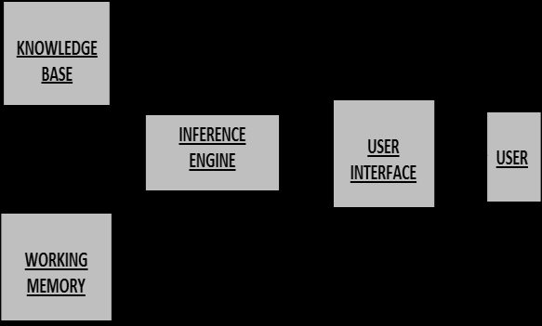

*Figure 1: Structure of an expert system*

Figure 1 above shows the structure of a medical expert system. Assuming the user interface acts as a physician or a patient, the user will answer a few questions about their conditions and the physician might need to add more medical data about a patient to help solve the problem.

### 2.4.1 THE KNOWLEDGE BASE

The knowledge base is the heart of the expert system (5). It is the collection of facts and rules which describe all the knowledge about problem domain (4). It takes a collection of relevant knowledge that is stored in a computer and organizes the information in such a way that it can be used for inferences. These inferences are generally in the form of IF-THEN rules (5) that make use of various tests to rule in or out a diagnosis. These tests are scheduled based on suspicion of disease (14). Most of these systems are based on the concept of production rules (12), hence a rule is defined as “an IF-THEN” type structure which relates some known information contained in the “IF” part to other information. This information can then be concluded to be contained in the “THEN” part (4).

Example

*RULE 1:*

IF Battery is dead

THEN Car will not start

*RULE 2:*

IF Battery voltage is below 10 volts

THEN Battery is dead

These two rules capture knowledge which represents natural relationships for automobile diagnostics. However, Rule 1 relates the status of the battery to the status of the car and Rule 2 relates the status of the battery to its own status. Each rule is a separate declarative statement about the problem, allowing one to add rules to the system (4).

## 2.5 DEPRESSION

Depression is not just a form of extreme sadness. It is a disorder that affects both brain and body, including cognition, behavior, the immune system and peripheral nervous system. Unlike a passing sad mood, depression is considered a disorder because it interferes with ordinary functioning in work, school, or relationships. Unlike normal grief, which comes in waves, it is constant and oppressive. Depression also differs from ordinary mourning in that the mourner experiences the world as empty or bad, whereas clinically depressed individuals locate their sense of emptiness or badness in the self. (PDM Task Force, 2006, p. 109) Depression varies in intensity, from mild to extremely severe, and its symptoms can range from subtle to substantially disabling*.*

Affective symptoms include loss of pleasure and interest in life or activities the individual previously enjoyed (anhedonia); feelings of worthlessness, guilt, inferiority, inadequacy, helplessness, and weakness; and an overwhelming sense of sadness, despair, loss of hope, and self-hatred. Cognitive symptoms include impaired concentration and memory, indecisiveness, rationalization of guilt, and sustained and intense self criticism. Suicidal ideation of varying intensity is common in depressed individuals. Somatic symptoms are common among people with depression and can include fatigue, lethargy, sleep disruption (hypersomnia or insomnia), restlessness and agitation, headache, muscular pain, back pain, weight loss or gain (and associated appetite changes), and loss of sexual desire. A greater number and severity of somatic symptoms has been associated with treatment-resistant depression (TRD) (Papakostas et al., 2003).

### 2.5.1 Subtypes of Depression: Anaclitic and Introjective Depression Subtypes.

Sidney Blatt (1974) and a number of hiscolleagues identified two subtypes of depression: anaclitic and introjective depression. Blatt’s theories were based on a range of research into depression rather than being focused on symptoms, as are standard diagnostic systems*.* Instead, Blatt’s theories focused on the internal experience, preoccupations, and life experiences of individuals with depression.

They are primarily psychodynamic in nature, but his conceptions of anaclitic and introjective depression also correspond, respectively, to A.T. Beck’s (1983) subtypes of sociotropic and autonomous depression and are similar to Bowlby’s(1977, 1980, 1988) concepts of ambivalent and anxious attachment patterns.

Anaclitic depression is characterized by feelings of loneliness, helplessness, and weakness; the individual has intense and chronic fears of being abandoned and left

Unprotected and uncared for. Thus, these individuals have a desperate need to keep in close physical contact with need-gratifying others, and they experience deep longings to be loved, cared for, nurtured, and protected. Others are valued primarily for the care, comfort, and satisfaction they can provide because there has been little internalization of the experiences of gratification or of the qualities of the individuals who provided satisfaction. These dependent individuals rely intensely on others to provide and maintain a sense of well-being, and therefore they have great difficulty expressing anger for fear of losing the need gratification others can provide. Separation from others and loss are sources of considerable fear and apprehension, and are often dealt with by primitive means such as denial and/or a desperate search for substitutes (Blatt, 1974).

Introjective depression, in contrast, is characterized by self-criticism and feelings of unworthiness, inferiority, failure, and guilt. These individuals engage in constant and harsh self-scrutiny and evaluation and have a chronic fear of being disapproved and criticized, and of losing the approval and acceptance.

### 2.5.2 Depression: Patterns of Natural Course, Relapse, and Recovery

It is difficultto make accurate statements about the naturalcourse of depression because it is possible thatmany people experience depressions that, due to factors such as embarrassment and underreporting, are not identified in prevalence studies.The course of depression and prognostic indicatorsvary considerably according to type andnumber of previous episodes.

Symptoms of major depressive disorder (MDD) typically develop over a period of between several days and a number of weeks, although early indicators of an impending depressive episode (prodromal symptoms) can occur several months before the onset of a depressive episode that meets statistical standard of mental disorder (*DSM)* criteria.

The duration of a major depressive episode (MDE) is variable, although in many cases it is between 6 months and 2 years. Between 5-10% of all individuals continue to meet criteria for MDD for 2 or more years. Despite not meeting diagnostic criteria for MDD, it is probable that many people continue to experience depressive symptoms for a prolonged period of time (American Psychiatric Association, 1994). Forty percent of people will continue to meet diagnostic criteria 1 year after diagnosis of MDD, 20% will continue to have some symptoms without meeting full diagnostic criteria (partial remission), and 40% will have no mood disorder. Initial severity of the episode appears to be predictive

of its persistence, with more severe episodes lasting longer.

*DSM-IV* criteria for recovery from MDD are that the individual must not have met diagnostic criteria (i.e., depressed mood or loss of interest or pleasure plus four additional symptoms) for a period of 2 consecutive months. Throughout this time, an individual may still have a number of depressive symptoms, in

which case the individual is considered to be in partial remission.

*Relapse Rates.* A study by Piccinelli and Wilkinson (1994) found that 75% of people with MDD would have at least one further episode of depression within 10 years. Ten percent of patients in their study had experienced chronic and persistent depression for a period of 10 years. The *DSM-IV* states that approximately

50%-60% of individuals who experience a single MDE will go on to have a second episode. Individuals who have had two episodes have a 70% chance of having a third, and individuals who have had three episodes have a 90% chance of having a fourth. Clearly, the number of episodes is a predictor of the chance of recurring episodes of major depression. There is a greater likelihood of an individual

experiencing another episode of depression when there is only partial remission (i.e., some symptoms remain). While psychosocial stressors (such as relationship problems or bereavement) are often associated with the first or second episode, they are less often associated with subsequent episodes. People with dysthymia have a high probability of eventually having an MDE, with estimates as high as 79% of people with dysthymia going on to develop an MDD during their lifetime. People who have had an MDD and who have an underlying dysthymic disorder will also have a much higher rate of relapse for an MDD, with 62% experiencing an MDE within 2 years (Keller, Lavori, Endicott, Coryell, & Klerman, 1983).

2.5.3. Patterns of Symptomatic Recovery and Relapse *in Psychotherapy.*

In their study on patterns of symptomatic recovery in time-limited (cognitive-behavioral or interpersonal) psychotherapy conducted with a sample of 212 depressed patients, Barkham et al. (1996) found that percentages of patients meeting criteria for clinically significant change (measured by change from a distressed/symptomatic score to a non distressed/asymptomatic score on each of the 21 items of the Beck Depression Inventory; see A. T. Beck, Steer, & Brown, 1996; A. T. Beck, Ward, Mendelssohn, & Erbaugh, 1961) ranged from 34% to 89% within 16 sessions of therapy. In measurements of the 14 symptoms

(including guilt, crying, and pessimism) showing the fastest and largest change, between 50% and 89% of patients had achieved nondistressed/ asymptomatic scores on all items after 16 sessions of psychotherapy. Kopta, Howard, Lowry, and Beutler (1994) examined patterns of symptomatic recovery among a sample of 854 patients in ongoing (not time-limited) outpatient psychotherapy measured

using the Symptom Checklist-90 (SCL- 90-R) (Derogatis, 1983). The study identified three categories of symptoms: acute, chronic,

## 2.6 ARTIFICIAL INTELLIGENCE

From SIRI to self-driving cars, artificial intelligence (AI) is progressing rapidly. While science fiction often portrays AI as robots with human-like characteristics, AI can encompass anything from Google’s search algorithms to IBM’s Watson to autonomous weapons. Artificial intelligence today is properly known as narrow AI (or weak AI), in that it is designed to perform a narrow task (e.g. only facial recognition or only internet searches or only driving a car). However, the long-term goal of many researchers is to create general AI (AGI or strong AI). While narrow AI may outperform humans at whatever its specific task is, like playing chess or solving equations, AGI would outperform humans at nearly every cognitive task.

### 2.6.1 WHY RESEARCH ARTIFICIAL INTELLIGENCE SAFETY?

In the near term, the goal of keeping AI’s impact on society beneficial motivates research in many areas, from economics and law to technical topics such as verification, validity, security and control. Whereas it may be little more than a minor nuisance if your laptop crashes or gets hacked, it becomes all the more important that an AI system does what you want it to do if it controls your car, your airplane, your pacemaker, your automated trading system or your power grid. Another short-term challenge is preventing a devastating arms race in lethal autonomous weapons. In the long term, an important question is what will happen if the quest for strong AI succeeds and an AI system becomes better than humans at all cognitive tasks. As pointed out by I.J. Good in 1965, designing smarter AI systems is itself a cognitive task. Such a system could potentially undergo recursive self-improvement, triggering an intelligence explosion leaving human intellect far behind. By inventing revolutionary new technologies, such a super intelligence might help us eradicate war, disease, and poverty, and so the creation of strong AI might be the biggest event in human history. Some experts have expressed concern, though, that it might also be the last, unless we learn to align the goals of the AI with ours before it becomes super intelligent.

There are some who question whether strong AI will ever be achieved, and others who insist that the creation of super intelligent AI is guaranteed to be beneficial. At FLI we recognize both of these possibilities, but also recognize the potential for an artificial intelligence system to intentionally or unintentionally cause great harm. We believe research today will help us better prepare for and prevent such potentially negative consequences in the future, thus enjoying the benefits of AI while avoiding pitfalls.

### 2.6.2 HOW CAN ARTIFICIAL INTELLIGENCE BE DANGEROUS?

Most researchers agree that a super intelligent AI is unlikely to exhibit human emotions like love or hate, and that there is no reason to expect AI to become intentionally benevolent or malevolent. Instead, when considering how AI might become a risk, experts think two scenarios most likely:

The AI is programmed to do something devastating: Autonomous weapons are artificial intelligence systems that are programmed to kill. In the hands of the wrong person, these weapons could easily cause mass casualties. Moreover, an AI arms race could inadvertently lead to an AI war that also results in mass casualties. To avoid being thwarted by the enemy, these weapons would be designed to be extremely difficult to simply “turn off,” so humans could plausibly lose control of such a situation. This risk is one that’s present even with narrow AI, but grows as levels of AI intelligence and autonomy increase.

The AI is programmed to do something beneficial, but it develops a destructive method for achieving its goal: This can happen whenever we fail to fully align the AI’s goals with ours, which is strikingly difficult. If you ask an obedient intelligent car to take you to the airport as fast as possible, it might get you there chased by helicopters and covered in vomit, doing not what you wanted but literally what you asked for. If a super intelligent system is tasked with a ambitious geoengineering project, it might wreak havoc with our ecosystem as a side effect, and view human attempts to stop it as a threat to be met.

As these examples illustrate, the concern about advanced AI isn’t malevolence but competence. A super-intelligent AI will be extremely good at accomplishing its goals, and if those goals aren’t aligned with ours, we have a problem. You’re probably not an evil ant-hater who steps on ants out of malice, but if you’re in charge of a hydroelectric green energy project and there’s an anthill in the region to be flooded, too bad for the ants. A key goal of AI safety research is to never place humanity in the position of those ants.

### 2.6.3 WHY THE RECENT INTEREST IN ARTIFICIAL INTELLIGENCE SAFETY

Stephen Hawking, Elon Musk, Steve Wozniak, Bill Gates, and many other big names in science and technology have recently expressed concern in the media and via open letters about the risks posed by AI, joined by many leading AI researchers. Why is the subject suddenly in the headlines?

The idea that the quest for strong AI would ultimately succeed was long thought of as science fiction, centuries or more away. However, thanks to recent breakthroughs, many AI milestones, which experts viewed as decades away merely five years ago, have now been reached, making many experts take seriously the possibility of super intelligence in our lifetime. While some experts still guess that human-level AI is centuries away, most AI researches at the 2015 Puerto Rico Conference guessed that it would happen before 2060. Since it may take decades to complete the required safety research, it is prudent to start it now. Because AI has the potential to become more intelligent than any human, we have no surefire way of predicting how it will behave. We can’t use past technological developments as much of a basis because we’ve never created anything that has the ability to, wittingly or unwittingly, outsmart us. The best example of what we could face may be our own evolution. People now control the planet, not because we’re the strongest, fastest or biggest, but because we’re the smartest. If we’re no longer the smartest, are we assured to remain in control?

FLI’s position is that our civilization will flourish as long as we win the race between the growing power of technology and the wisdom with which we manage it. In the case of AI technology, FLI’s position is that the best way to win that race is not to impede the former, but to accelerate the latter, by supporting AI safety research.

### 2.6.4 THE TOP MYTHS ABOUT ADVANCED

A captivating conversation is taking place about the future of artificial intelligence and what it will/should mean for humanity. There are fascinating controversies where the world’s leading experts disagree, such as: AI’s future impact on the job market; if/when human-level AI will be developed; whether this will lead to an intelligence explosion; and whether this is something we should welcome or fear. But there are also many examples of of boring pseudo-controversies caused by people misunderstanding and talking past each other. To help ourselves focus on the interesting controversies and open questions and not on the misunderstandings let’s clear up some of the most common myths.

### 2.6.5 TIMELINE MYTHS

The first myth regards the timeline: how long will it take until machines greatly supersede human-level intelligence? A common misconception is that we know the answer with great certainty. One popular myth is that we know we’ll get superhuman AI this century. In fact, history is full of technological over-hyping. Where are those fusion power plants and flying cars we were promised we’d have by now? AI has also been repeatedly over-hyped in the past, even by some of the founders of the field. For example, John McCarthy (who coined the term “artificial intelligence”), Marvin Minsky, Nathaniel Rochester and Claude Shannon wrote this overly optimistic forecast about what could be accomplished during two months with stone-age computers: “We propose that a 2 month, 10 man study of artificial intelligence be carried out during the summer of 1956 at Dartmouth College […] An attempt will be made to find how to make machines use language, form abstractions and concepts, solve kinds of problems now reserved for humans, and improve themselves. We think that a significant advance can be made in one or more of these problems if a carefully selected group of scientists work on it together for a summer.” On the other hand, a popular counter-myth is that we know we won’t get superhuman AI this century. Researchers have made a wide range of estimates for how far we are from superhuman AI, but we certainly can’t say with great confidence that the probability is zero this century, given the dismal track record of such techno-skeptic predictions. For example, Ernest Rutherford, arguably the greatest nuclear physicist of his time, said in 1933 less than 24 hours before Szilard’s invention of the nuclear chain reaction that nuclear energy was “moonshine.” And Astronomer Royal Richard Woolley called interplanetary travel “utter bilge” in 1956. The most extreme form of this myth is that superhuman AI will never arrive because it’s physically impossible. However, physicists know that a brain consists of quarks and electrons arranged to act as a powerful computer, and that there’s no law of physics preventing us from building even more intelligent quark blobs.There have been a number of surveys asking AI researchers how many years from now they think we’ll have human-level AI with at least 50% probability. All these surveys have the same conclusion: the world’s leading experts disagree, so we simply don’t know. For example, in such a poll of the AI researchers at the 2015 Puerto Rico AI conference, the average (median) answer was by year 2045, but some researchers guessed hundreds of years or more. There’s also a related myth that people who worry about AI think it’s only a few years away. In fact, most people on record worrying about superhuman AI guess it’s still at least decades away. But they argue that as long as we’re not 100% sure that it won’t happen this century, it’s smart to start safety research now to prepare for the eventuality. Many of the safety problems associated with human-level AI are so hard that they may take decades to solve. So it’s prudent to start researching them now rather than the night before some programmers drinking Red Bull decide to switch one on.

### 2.6.6 CONTROVERSY MYTHS

Another common misconception is that the only people harboring concerns about AI and advocating AI safety research are luddites who don’t know much about AI. When Stuart Russell, author of the standard AI textbook, mentioned this during his Puerto Rico talk, the audience laughed loudly. A related misconception is that supporting AI safety research is hugely controversial. In fact, to support a modest investment in AI safety research, people don’t need to be convinced that risks are high, merely non-negligible — just as a modest investment in home insurance is justified by a non-negligible probability of the home burning down. It may be that media have made the AI safety debate seem more controversial than it really is. After all, fear sells, and articles using out-of-context quotes to proclaim imminent doom can generate more clicks than nuanced and balanced ones. As a result, two people who only know about each other’s positions from media quotes are likely to think they disagree more than they really do. For example, a techno-skeptic who only read about Bill Gates’s position in a British tabloid may mistakenly think Gates believes superintelligence to be imminent. Similarly, someone in the beneficial-AI movement who knows nothing about Andrew Ng’s position except his quote about overpopulation on Mars may mistakenly think he doesn’t care about AI safety, whereas in fact, he does. The crux is simply that because Ng’s timeline estimates are longer, he naturally tends to prioritize short-term AI challenges over long-term ones.

## 2.7 RELATED WORK

IGAIN

The ‘IGain’ system is an expert system that provides an intelligent ‘Self Help’ Expert Solution for Depression patients.

The ‘IGain’ was proposed to be a web based system, accessible on computers as well as mobile devices. The system provides explicit and implicit inputs to the system to detect Depression disorder.

The ‘IGain’ system was meant to provide an intelligent ‘Self Help’ Expert Solution for Depression patients.

The proposed system has three types of users

1. Regular user (Patients or Potential Patients) – Type 1

2. Doctors / Counselors – Type 2

3. Buddies (Support Groups, People willing to help or share experience) – Type 3

Every type of user will create a user profile to store basic information. For Type 1 user, additional information which may include their hobbies, health inputs, habits, routine, preferences such as diet, doctor, entertainment, etc. will be input. These inputs will be stored in the knowledge Base and will directly be used to derive the support provided to the patient by IGain App.

For Type 2 and Type 3 users, system will input and store area of expertise, location, availability details, etc.

All users can update their IGain data, at any frequency, in any number of interactions

The system uses a Prolog Knowledge base which is initially fed with following data vetted by appropriate medical personnel:

1. Information related to Types and Levels of Depression, Symptoms of Depression, etc.

2. Conditions to identify possibility of Depression from Symptoms (Direct Symptoms, Keyword Based, etc.)

3. Base data on types and courses of treatment for various levels. This information can be used to suggest possible treatments for a patient, on case to case basis.

# CHAPTER THREE

# ANALYSIS AND DESIGN

## 3.0 INTRODUCTION

In this chapter we will takes an overview on the system design and the entire research work; we will present a skeletal approach to the design and analysis of the whole system.

System analysis has to do with the process of studying a procedure or a system in order to identify its goals and purposes and create systems and procedures that will achieve them in an efficient way.

## 3.1    Analysis of the Existing System

In this part of the world (Nigeria) the existing system for managing depression is still the use of human experts, this requires interactions between therapist and patience either directly in the same physical location or through mediums like video call, chat rooms, telephone calls and so on. The therapist ask the patience questions related to their symptoms gets feedback from the patience then make a diagnosis of the type of depression and make appropriate prescriptions, this system is effective in regions with adequate exposure to health education about depression and modern health care facilities, but less effective in region where people are less informed about depressive symptoms.

### 3.1.1    Advantages of the Existing System

The current systems of managing depression do have some advantages and they are:

1. The system does the job of diagnosing depressive cases and managing them properly.
2. The system encourages extensive interaction between therapist and patients.
3. The system keeps track of patients’ progress until fully recovered.
4. The system keeps adequate record of patients past diagnosis and prescriptions.

### 3.1.2    Disadvantages of the Existing System

The weakness of the existing system includes:

1. The existing system is not fully automated, that is, it still requires booking of appointments with the therapist, that makes it a first come first serve system and the implication of that is that patients will wait in line for the limited therapist available to get to them.
2. The existing system is not very efficient as it take more time and resource to get in a session with a therapist.
3. A lot of people in this part of the world (Nigeria) still see depression and other related cases of mental illness as something to be ashamed of and so may prefer to keep their situation private.
4. The issue of affordability is another key issue as many persons (especially those in the rural communities and low income level citizens) may not be able to afford the services of a human expert.

## 3.2    Analysis of the Proposed System

Most cases of depression are usually mild and mostly do not require a visit to a therapist so long as the patient knows a few things to do to manage the situation, in some cases just taking a walk for a few minutes can bring some improvement, even a change in diet can turn a situation around. The proposed system will use expert knowledge to diagnose the type of depression and the severity and give advice on how to manage the situation. The system will be web based and will not require any appointment with a human expert as the system will be fully automated and will utilize the knowledge of experts in the knowledge base to make diagnoses and suggest possible ways to manage the situation. The patient will not be required to sign up or login to use the system to maintain the user’s privacy as most users will prefer to remain anonymous.

### 3.2.1 Advantages of the proposed system

Some of the advantages of the proposed system are as follows:

1. Availability: the proposed system is always available, does not go on holidays or breaks all you need is an internet enabled device and access to the internet.
2. Accessibility: the system can be accessed by anyone from any location, at the same time, no queue or booking of appointment is required
3. Privacy: access to the system will be anonymous, anyone can take the test and get help without need to feel ashamed or have a feeling that someone is mining their data.
4. It will save the user a lot of time and money as the assessment time will be very fast and the platform will be totally free of charge.

### 3.2.2 Disadvantages of the Proposed System

The proposed system has two major setbacks and they are:

1. The system will be web based and so cannot be access without internet connection and internet enabled device.
2. The second drawback is that severe cases of depression like clinical depression that requires prescription of medication will not be managed by the system as such cases requires close monitoring by a human expert.

## 3.3    Methodology

The methodology adopted for the development of this system is the rule based expert system methodology.

A rule-based expert system is a system that contains set of rules that are used to describe certain patterns. Observed data are collected and evaluated using these rules. If the rules are logically satisfied, the pattern is identified, and a problem associated with that pattern is suggested. Each particular problem (symptom) might imply a specific treatment. These rules do not take into consideration the uncertainty and the impreciseness of human observed data and reasoning and real world knowledge that characterized by incompleteness, inaccuracy, and inconsistency. The rule-based approach uses IF-THEN type rules. IF-THEN rules take the following form: IF there is a flame THEN there is a fire.

## 3.4    System Design

The proposed system will have three basic components:

1. . A list of rules base, which is a specific type of knowledge base as it relates to depression.
2. . An inference engine, which infers information or takes action based on the interaction of input (user symptoms) and the rule base.
3. . A user interface through which input and output signals are received and sent. The user can be either the knowledge engineer inputting new symptoms into the knowledge base or the patient that is taking a test on the platform.

The proposed system design is as shown in fig 3.1 below

USER INTERFACE

DATA BASE/

RULE BASE

(Symptoms)

INFERENCE

ENGINE

RESULT AND

EXPLANATION

FACILITIES

**Fig 3.1 Design of proposed system**

## 3.5    Use Case Diagram

The use case diagram is shown below in figure 3.2. The knowledge engineer enters the symptoms into the knowledge base by login into the system, the patient visits the page takes the test and views his or her result.

Knowledge

Engineer

Patient

Fig 3.2 Use case Diagram for Depression Management Expert System

## 3.6 Proposed System Flow Chart

Start

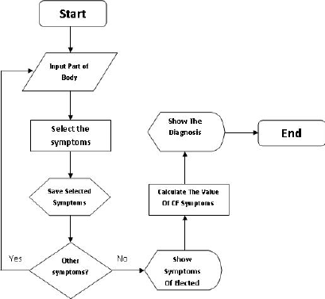

Login

Start Test

Yes

No

Admin

Select Symptom

View Symptoms List

Add Symptoms To Database

Save Selected Symptom

No

Yes

Other Symptoms?

Calculate Value OF Symptoms

Stop

Show Result

Fig 3.3 Proposed System Flow Chart.

## 3.6 Software Requirements

1. Operating system- Windows and mobile operating system is used as the operating system as it is stable and supports more features and is more users friendly.
2. Database MYSQL-MYSQL is used as database as it easy to maintain and retrieve records by simple queries which are in English language which are easy to understand and easy to write.
3. Development tools and Programming language- HTML and is used to write the whole code and develop webpages with cascading style sheet, java script for manipulating the document object model(DOM) and hypertext pre-processor (PHP) for sever side scripting.

### 3.6.1 Software tools used

The whole Project is divided in two parts the front end and the back end.

**FRONT END:** The front end is designed using of HTML, CSS, Java script

1. **HTML**- HTML or Hyper Text Mark-up Language is the main mark-up language for creating web pages and other information that can be displayed in a web browser.HTML is written in the form of HTML elements consisting of tags enclosed in angle brackets (like <html>), within the web page content. The purpose of a web browser is to read HTML documents and compose them into visible or audible web pages. It provides a means to create structured documents by denoting structural semantics for text such as headings, paragraphs, lists, links, quotes and other items. It can embed scripts written in languages such as JavaScript which affect the behaviour of HTML web pages.
2. **CSS**- Cascading Style Sheets (CSS) is a style sheet language used for describing the look and formatting of a document written in a mark-up language. While most often used to style web pages and interfaces written in HTML and XHTML, the language can be applied to any kind of XML document, including plain XML, SVG and XUL. CSS is a cornerstone specification of the web and almost all web pages use CSS style sheets to describe their presentation.CSS is designed primarily to enable the separation of document content from document presentation, including elements such as the layout, colours, and fonts. It can also be used to allow the web page to display differently depending on the screen size or device on which it is being viewed.
3. **JAVA SCRIPT**- JavaScript (JS) is a dynamic computer programming language. It is most commonly used as part of web browsers, whose implementations allow client side scripts to interact with the user, control the browser, communicate asynchronously, and alter the document content that is displayed. It is also being used in server-side programming, game development and the creation of desktop and mobile applications. JavaScript is a prototype-based scripting language with dynamic typing and has first- class functions. Its syntax was influenced by C. JavaScript copies many names and naming conventions from Java, but the two languages are otherwise unrelated and have very different semantics. The key design principles within JavaScript are taken from the self and Scheme programming languages. It is a metaparadigm language, supporting object-oriented, imperative, and functional programming styles.

**BACK END-** The back end is designed using MySQL which is used to design the databases and PHP which is a scripting language for server side.

1. **MYSQL**- MySQL ("My S-Q-L", officially, but also called "My Sequel") is (as of July 2013) the world's second most widely used open-source relational database management system (RDBMS). It is named after co-founder Michael Widenius daughter, My. The SQL phrase stands for Structured Query Language. The MySQL development project has made its source code available under the terms of the GNU General Public License, as well as under a variety of proprietary agreements. MySQL was owned and sponsored by a single for- profit firm, the Swedish company MySQLAB, now owned by Oracle Corporation. MySQL is a popular choice of database for use in web applications, and is a central component of the widely used LAMP open source web application software stack (and other 'AMP' stacks). LAMP is an acronym for "Linux, Apache, MySQL, Perl/PHP/Python." Free-software-open source projects that require a full-featured database management system often use MySQL. For commercial use, several paid editions are available, and offer additional functionality. Applications which use MySQL databases include: TYPO3, MODx, Joomla, WordPress, phpBB, MyBB, Drupal and other software. MySQL is also used in many high-profile, large-scale websites, including Wikipedia, Google (though not for searches), Facebook, Twitter, Flickr, and YouTube.
2. **PHP**- PHP is a server-side scripting language designed for web development but also used as a general-purpose programming language. PHP is now installed on more than 244 million websites and 2.1 million web servers. Originally created by RasmusLerdorf in 1995, the reference implementation of PHP is now produced by The PHP Group. While PHP originally stood for Personal Home Page, it now stands for PHP: Hypertext Pre-processor, a recursive backronym.PHP code is interpreted by a web server with a PHP processor module, which generates the resulting web page: PHP commands can be embedded directly into an HTML source document rather than calling an external file to process data. It has also evolved to include a command-line interface capability and can be used in standalone graphical applications. PHP is free software released under the PHP License. PHP can be deployed on most web servers and also as a standalone shell on almost every operating system and platform, free of charge.

## 3.7 Hardware Requirements

A laptop, desktop, tablet or mobile device with at least 1gigabyte RAM and a functioning web browser e.g. Firefox and Chrome.

# CHAPTER FOUR

# SYSTEM DESIGN AND IMPLEMENTATION

## 4.1 Introduction

This chapter deals with the system implementation which is the actual development of the program and its documentation. The Hardware and Operating system requirement is also discussed here.

## 4.2 Objective of the new system

The objectives of the new system are:

1. To easily take a test (diagnosis of depression) and get the result and recommendation instantly.
2. Convenient user interface.
3. Easier end user interpretation.

## 4.3 Landing Page (Home Page)

The landing page or the home page is the first page a user sees when they visit the site. The landing page contains just two menu items: a link to admin(knowledge engineer) login and another link for the user(to take the test)

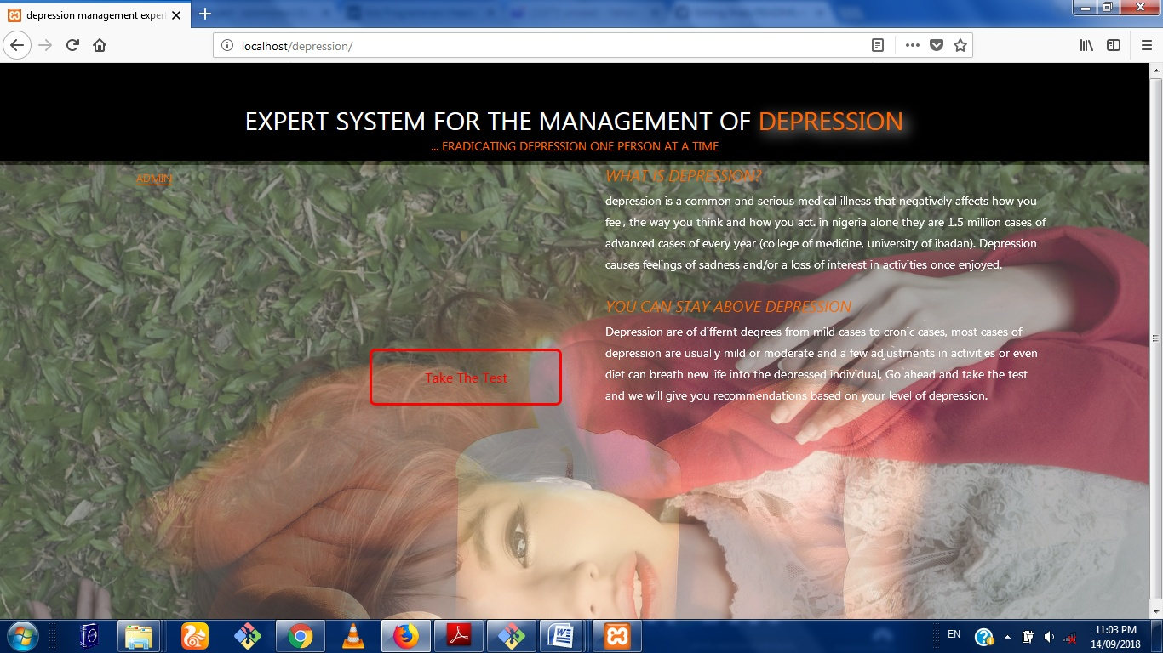

Fig 4.1: Main Menu

## 4.4 Database Specification

The database used in the design of this work is MySQL. A database with name of depression was created. It has two tables namely: admin and symptoms as shown in figure 4.2 below

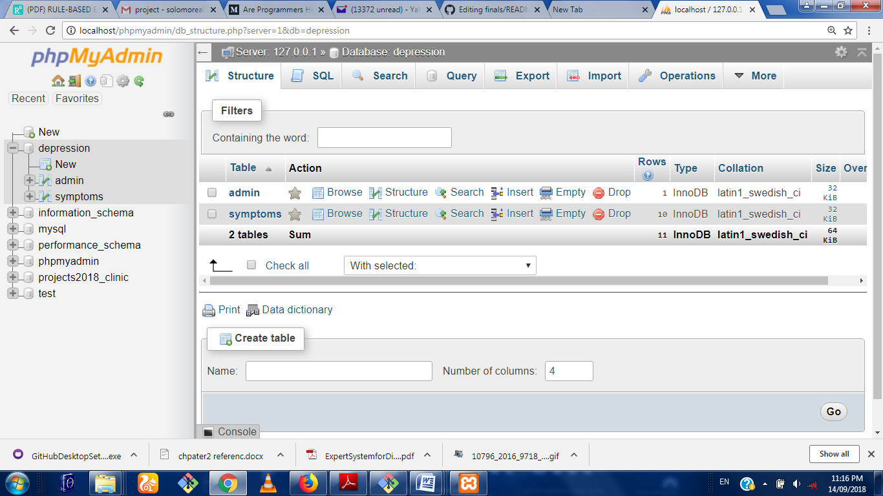.

Fig 4.2 Database

The specification for the admin table is shown in fig 4.3. In this table, the attributes used are id, username, and password, with data types of integer and variable character for storing alpha numeric character.

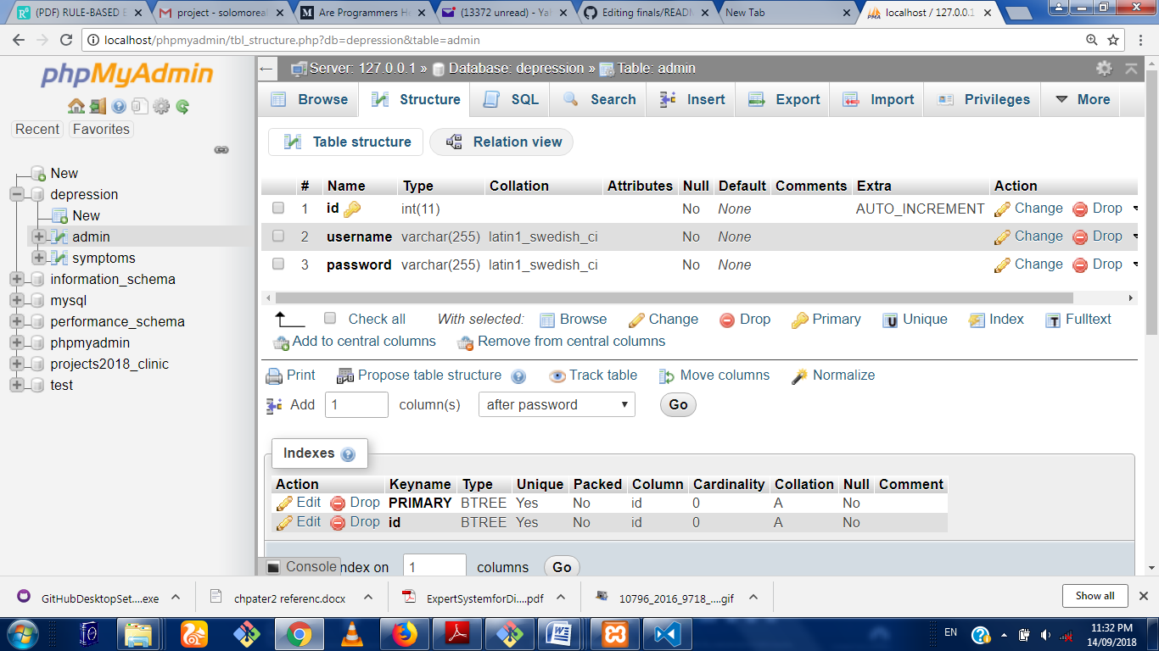

Fig 4.3

The specification for the Symptoms table is shown in Fig 4.4. In this table, the attributes used are id, and symptoms with data types of integer and variable character for storing alpha numeric characters.

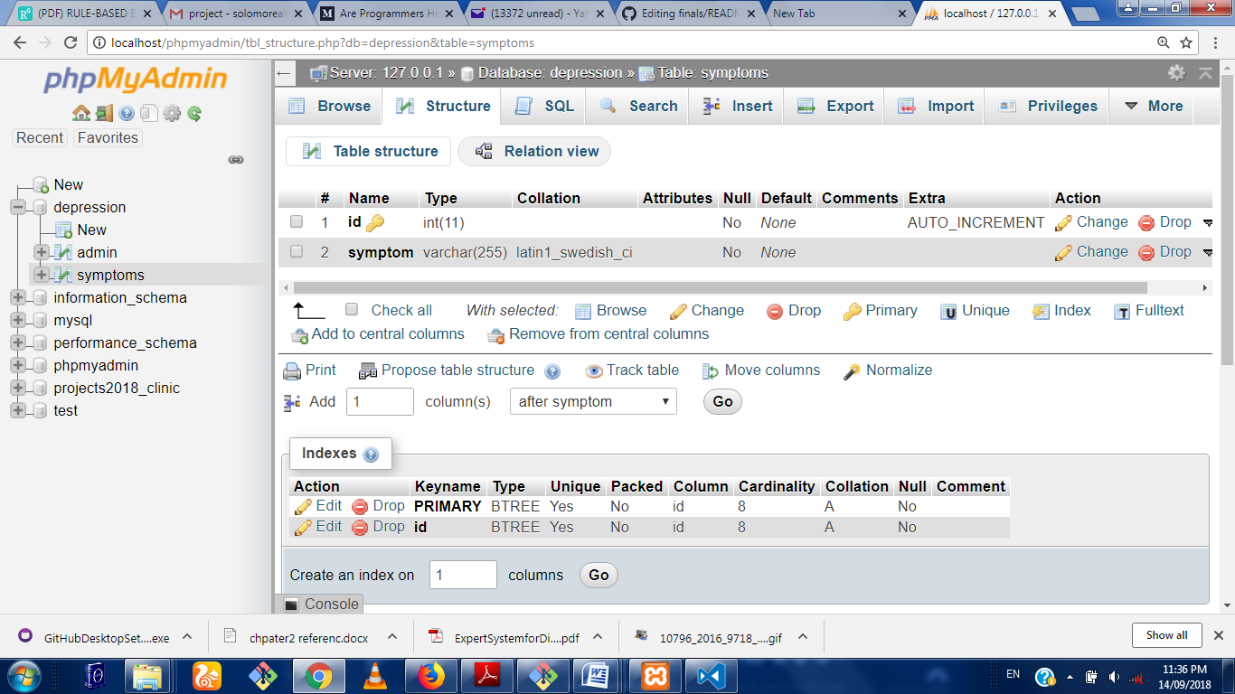

Fig 4.4

## 4.5 Input/Output Screen/Format

The input screen format shows the screen shot of all the input format in the program. The first input screen is the login page where the admin login to his dashboard.

This is shown in figure 4.5.

### 4.5.1 Login Module

This is the first point where the admin interacts with the program. The admin is required to enter his/her username and password and from here if authentication is successful, the admin dashboard.

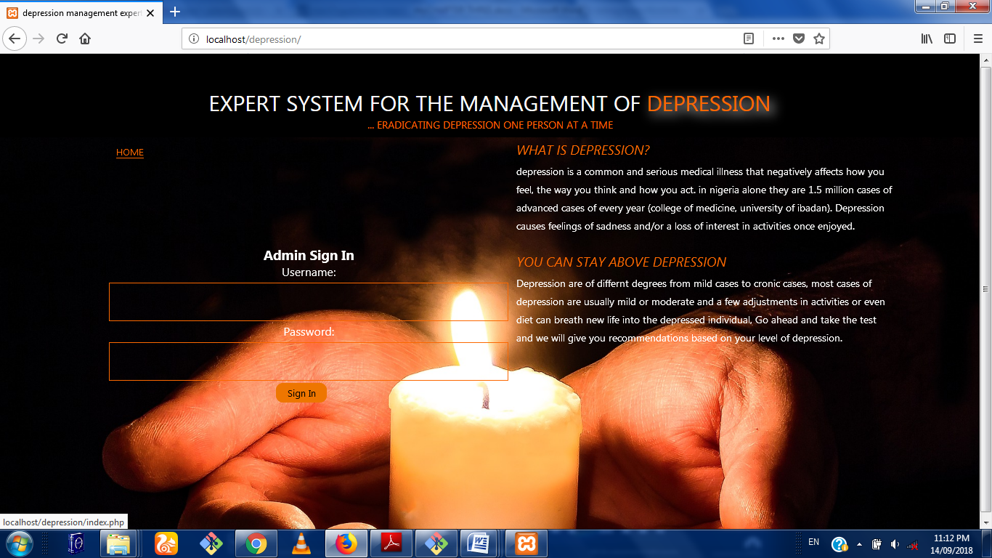

Fig 4.2: Login Module

### 4.5.3 Admin Symptom Input Module

This is a page linked to the admin dashboard where the admin can add or create a new symptom by inputting on the required text field. Once the admin clicks on the submit button, a new symptom will be added to the knowledge base.

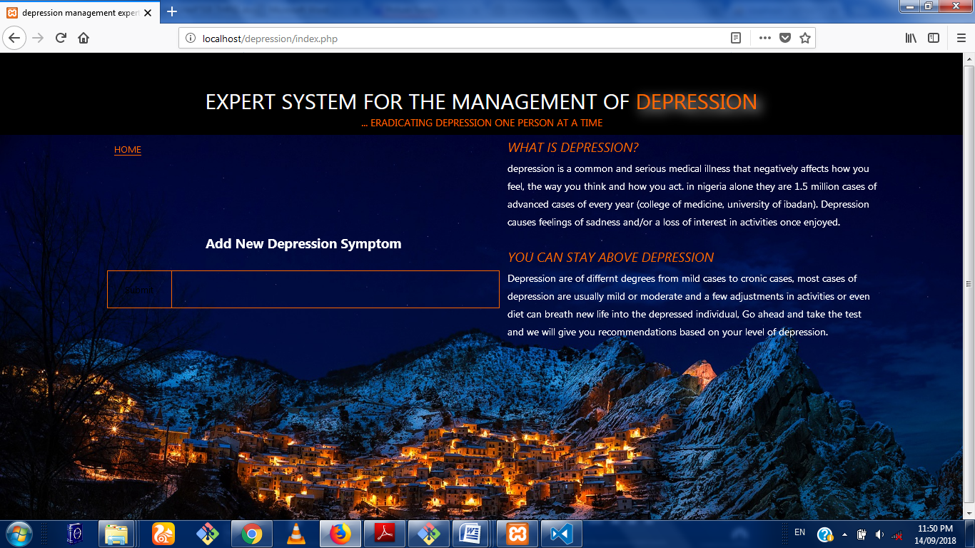Fig 4.4 Admin Input Module

### 4.5.4 Admin dashboard Symptom Output Module

This is the region where the Admin get to view all the symptoms he/she has added to the data base

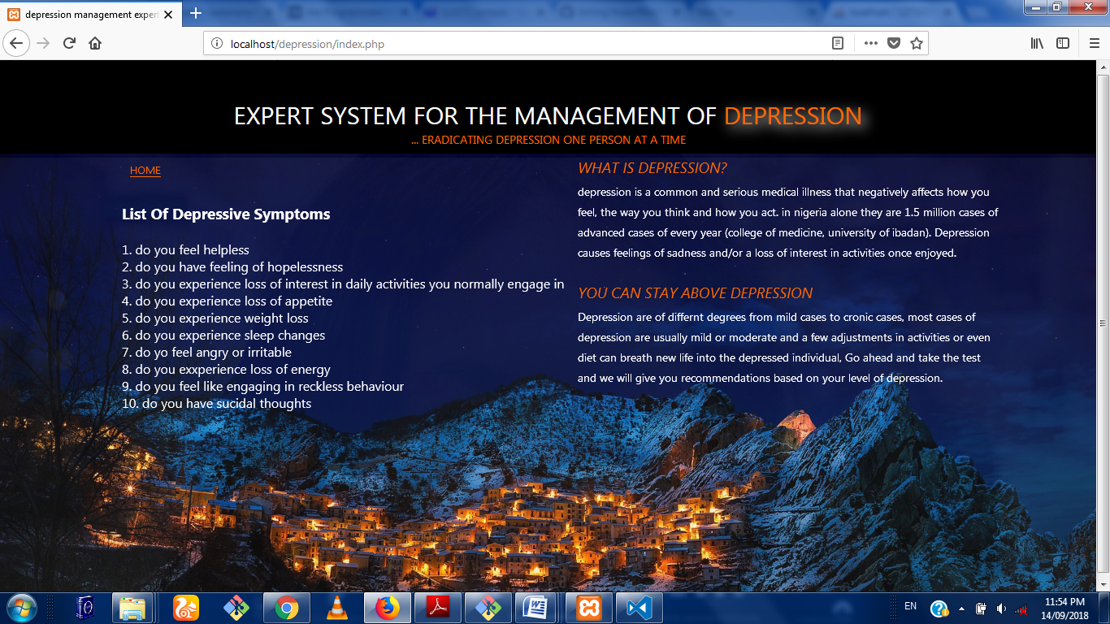Fig 4.5 Admin symptom Output Area

4.5.5 Patient Diagnosis Module

This is where the patient takes the test by answering a few questions relating to depressive symptoms

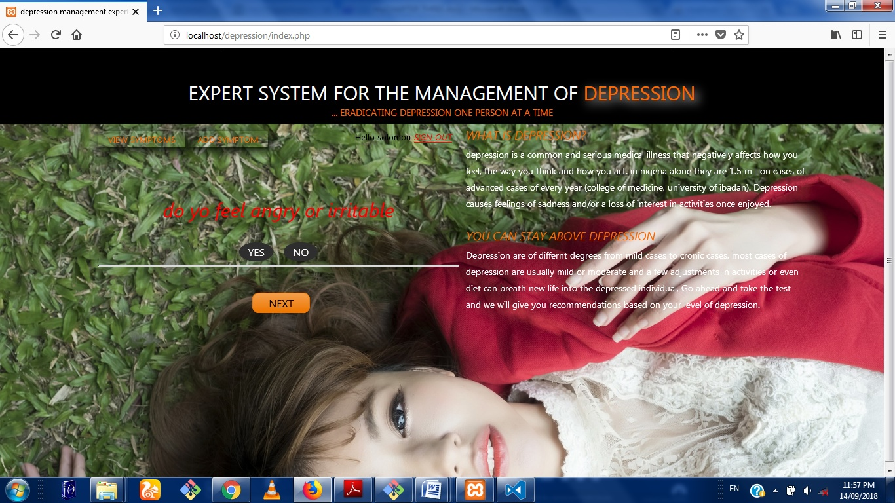

Fig 4.5 Testing Area.

### 4.5.6 Result Display Module

This is where the result of the patients diagnosis is displayed along side some expert advice

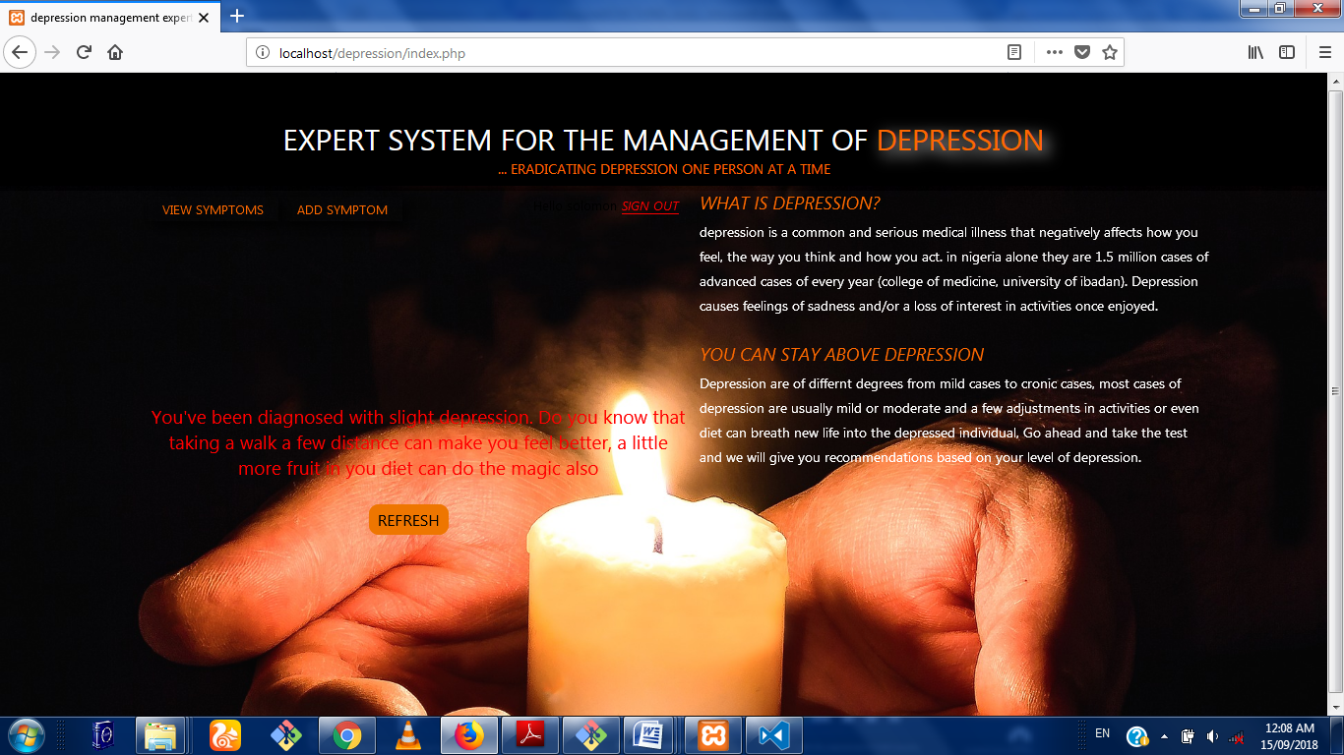

Fig 4.7 Result Area

## The 4.6 Hardware and Operating System requirement

The hardware and Software system needed to run the program include

### 4.6.1 Hardware Specifications

1. Processor Name: Intel Dual Core / AMD
2. Processor Speed: 1.66 GHz
3. RAM: 1 GB
4. Hard Disk Capacity: 50 GB
5. Display Device: 14’ to 19’ Inch Monitor
6. Keyboard Type: PS2 or USB
7. Mouse Type: PS2 or USB

### 4.6.2 Software Specifications:

1. Language Used: HTML, PHP,CSS,JAVASCRIPT, SQL
2. Software Used: MySql,xampp Server ,Php
3. Operating System: Windows XP/ Windows 7/ Windows8 / windows10/Linux

## 4.7 Software testing

Testing is the process of running a system with the intention of finding errors. Testing enhances the integrity of a system by detecting deviations in design and errors in the system. Testing aims at detecting error-prone areas. This helps in the prevention of errors in a system. Testing also adds value to the product by conforming to the user requirements. The main purpose of testing is to detect errors and error-prone areas in a system. Testing must be thorough and well-planned. A partially tested system is as bad as an untested system. And the price of an untested and under-tested system is high.

The implementation is the final and important phase. It involves user-training, system testing in order to ensure successful running of the proposed system. The user tests the system and changes are made according to their needs. The testing involves the testing of the developed system using various kinds of data. While testing, errors are noted and correctness is the made.

The objectives of testing are:

1. Testing is a process of executing a program with the intent of finding errors.
2. A successful test case is one that uncovers an as yet undiscovered error.

System testing is a stage of implementation, which is aimed at ensuring that the system works accurately and efficiently as per the user need, before the live operation commences. As stated before, testing is vital to the success of a system. System testing makes a logical assumption that if all parts of the system are correct, the goal will be successfully achieved. A series of tests are performed before the system is ready for the user acceptance test.

### 4.7.1 Testing Methods

System testing is the stage of implementation. This is to check whether the system works accurately and efficiently before live operation commences. Testing is vital to the success of the system. The candidate system is subject to a variety of tests: on line response, volume, stress, recovery, security and usability tests. A series of tests are performed for the proposed system is ready for user acceptance testing. The testing Steps are:

1. **Unit Testing;**Unit testing focuses efforts on the smallest unit of software design. This is known as module testing. The modules are tested separately. The test is carried out during programming stage itself. In this step, each module is found to be working satisfactory as regards to the expected output from the module.
2. **Integration Testing**

Data can be lost across an interface. One module can have an adverse effect on another, sub functions, when combined, may not be linked in desired manner in major functions. Integration testing is a systematic approach for constructing the program structure, while at the same time conducting test to uncover errors associated within the interface. The objective is to take unit tested modules and builds program structure. All the modules are combined and tested as a whole.

1. **Validation**

At the culmination of the integration testing, software is completely assembled as a package. Interfacing errors have been uncovered and corrected and a final series of software test begin in validation testing. Validation testing can be defined in many ways, but a simple definition is that the validation succeeds when the software functions in a manner that is expected by the customer. After validation test has been conducted, one of the three possible conditions exists.

a. The function or performance characteristics confirm to specification and are accepted.

b. A deviation from specification is uncovered and a deficiency lists is created.

c. Proposed system under consideration has been tested by using validation test and found to be working satisfactory.

1. **Output Testing**

After performing the validation testing, the next step is output testing of the proposed system, since no system could be useful if it does not produce the required output in a specific format. The output format on the screen is found to be correct. The format was designed in the system design time according to the user needs. For the hard copy also; the output comes as per the specified requirements by the user. Hence output testing did not result in any correction for the system.

1. **User Acceptance Testing**

User acceptance of a system is the key factor for the success of any system. The system under consideration is tested for the user acceptance by constantly keeping in touch with the prospective system users at the time of developing and making changes whenever required.

# CHAPTER FIVE

# SUMMARY, CONCLUSION AND RECOMMENDATIONS

## 5.1 Summary

In this work, the web based depression management expert system was developed to ensure easy access to expert diagnosis of depressive cases and to get appropriate advice on how to manage the situation. It was proposed to work side by side the existing system that involves the direct interaction with human experts. The pros and cons of both systems were discussed and a suitable module was developed to aid in the depression management process. An application was developed to show the proof of concept and from the result; the system is noted to have performed well.

## 5.2 Conclusion

The depression management expert system was developed and has proving from a series of test to be an effective tool in the management of depressive cases.

## 5.3 Recommendation

In this work the expert system methodology was used but a more efficient system could be build that uses machine learning algorithms to learn from every patient that uses the system thereby improving itself and showing advanced intelligence.